**K.M.A. Girls Secondary School Karachi**

**Class: 6th Subject: social Studies**

**Time: 30 minutes Marks: 35**

**Section A (Objective Questions)**

**1. Choose the correct answer for each from the given options. (5)**

1. Pakistan has ________ reserves of oil.

Huge little no

1. The Mongols were tribes who originally came from ________.

Iran Samarkand Mongolia

1. Basmati rice is grown only in ____________ .

Maldives and India Sri Lanka and Nepal Pakistan and India

1. Muhammad Ghori invaded ___________.

India Iran China

1. _____________ are inland seas.

Rivers Lakes Delta

1. Indus Valley Civilization flourished about _______ years ago.

3500 4000 4500

1. Mountains are usually above ___________ meters.

1000-2000 2000-3000 3000-4000

1. ___________ has the largest reservoirs of oil.

Venezuela Saudi Arabia Pakistan

1. Mohen jo Daro was about ___________ km all round.

6 7 8

1. In Pakistan, wheat is produced mainly in ____________.

Sindh Baluchistan Punjab

**2. Fill in the blanks: (5)**

1. Rice needs _____________ climate for its growth.
2. Leather from cattle is used for making _____________.
3. Indus Valley Civilization was situated in ____________.
4. The Silk Road linked China to _____________ and the subcontinent.
5. Natural gas turns into _____________ under pressure.

**3. In the outline map of Pakistan show the provinces and their capitals. (4)**

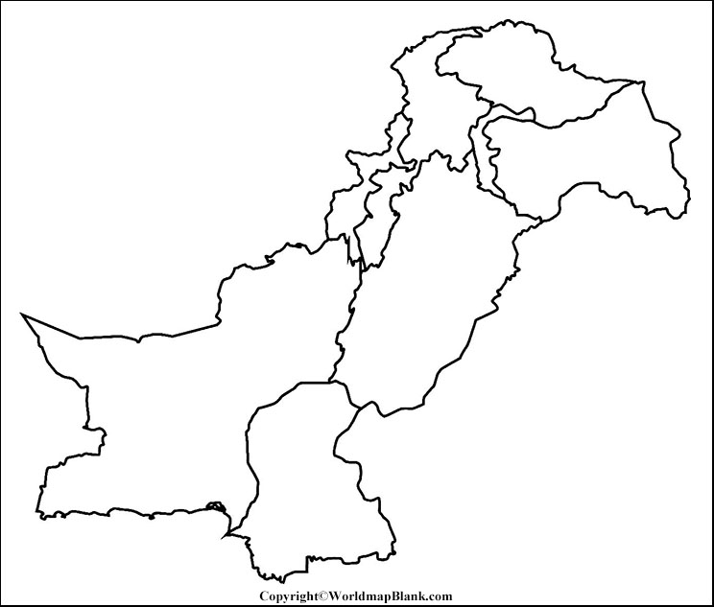

**4. Identify metallic and non-metallic minerals from the table and write them appropriately in their respective columns. (4)**

Iron Silver Coal Gold

Gypsum Limestone Diamond Uranium

|  |  |
| --- | --- |
| Metallic Minerals | Non-metallic Minerals |
|  |  |
|  |  |
|  |  |
|  |  |

**5. Match the columns correctly with the statements. (2)**

|  |  |
| --- | --- |
| Column A | Column B |
| Used in cooking | Oil |
| Used in brick making | Natural gas |
| Huge deposits in Saudi Arabia | India |
| 4th largest reserve of coal | Coal |

**6. Guess the personalities with the help of clues. (2)**

17 years old conquered Sindh Brave young man and a leader Nephew and son in law of Hajaj Bin Yousuf

4 years control and ruled India Daughter of Iltutmish

Personally lead her army Strong and brave young woman

**7. Give one word answer: (5)**

|  |  |
| --- | --- |
| He set up system of good governance. |  |
| The study of past human life. |  |
| National flower of Pakistan. |  |
| These crops provide food to the people. |  |
| Known as “Black Gold”. |  |

**8. Arrange the given steps of agriculture in the correct order, starting from first step to last step. (3)**

|  |  |  |
| --- | --- | --- |
| Irrigation | Sowing seeds | Preparation of soilT |
| Cutting of crops | Removing weeds | Packaging |

|  |
| --- |
| **Steps of Farming** |
| **Step1** |
| **Step 2** |
| **Step 3** |
| **Step 4** |
| **Step 5** |
| **Step 6** |

**9. Find the words related to crops given in the box below from puzzle. (2.5)**

|  |  |  |  |  |  |  |  |  |
| --- | --- | --- | --- | --- | --- | --- | --- | --- |
| C | B | R | I | C | E | C | D | E |
| O | F | G | H | I | J | T | K | L |
| T | O | P | O | N | A | M | L | E |
| T | U | A | B | E | A | N | P | N |
| O | V | B | H | P | E | F | G | T |
| N | N | W | G | I | J | K | S | I |
| Z | X | C | H | L | M | N | W | L |

**10. Unscramble the scrambled words. (2.5)**

|  |  |
| --- | --- |
| NABHEC |  |
| TUSLAJ |  |
| DSUNI |  |
| IAVR |  |
| LUMEJH |  |

**K.M.A. Girls Secondary School Karachi**

**Class: 6TH Subject: Social Studies**

**Time: 2 1/2 Hours Marks: 40**

**Section B (Short Answer Questions)**

**Q:11 Answer any 10 questions from this section. (20)**

1. What is meant by petroleum?
2. Write down the names of South Asian countries in alphabetical order?
3. Who were the first people to enter present day Pakistan?
4. What are the types of crops?
5. Why Razia Sultana took control and ruled all over India?
6. Which provinces of Pakistan are the best for growing wheat?
7. What do you know about Mongols?
8. Modern Pakistan has a wide range of races, languages, and customs. Why is this so?
9. What does the word Pakistan mean?
10. Which minerals are the source of producing energy or electricity?
11. Name some of the sources used to produce sugar?
12. Who demanded that Raja Dahir of Sindh should return the prisoners and treasure?

**Section C (Detailed Answer Questions)**

**Q:12 Answer any 5 questions from this section. (20)**

1. Why is Pakistan’s own coal not very important in industry at the moment?
2. Do you think Muhammad bin Qasim was popular rule? Why?
3. Why is butter difficult to store and transport in hot weather?
4. Why Indus valley civilization declined?
5. Explain why India and Pakistan together are called a subcontinent?
6. What advantages does natural gas have over oil? What ways is oil more useful?
7. What are the important features of Indus Valley Civilization?
8. Why do you think, does the Punjab have the highest population in the country?